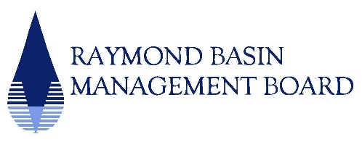

Executive Committee
January 6, 2026
1:30 p.m.

Conference Room
Main San Gabriel Basin Watermaster
725 North Azusa Avenue
Azusa, CA 91702

Chair: Chris Burt

Teleconference Accessibility Instructions

Zoom Meeting ID link | Dial by your location
RBMB Executive Comm Mtg._010626 | Dial Number: (669) 900-6833
Meeting ID: 822 6051 2848 | Meeting ID: 822 6051 2848
Passcode: 748145 | Passcode: 748145
_____________________________________________________________
AGENDA

- RBMB Election of Officers and Directors for Fiscal Years 2026-28
- Appointment of Nominating Committee
- Certification of Appointment

- Consideration and Recommendation of Proposal of the Watermaster Administrative Services Agreement for the Raymond Basin Management Board (materials to follow)

- Request from Las Flores Water Company for 24% Reduction Exemption

- Metropolitan Water District of Southern California Cyclic Cost Offset Program (materials to follow)

- Website Upgrades

- 2026 Board and Committee Meeting Dates

- Committee Assignments

- Review Agenda for January 21, 2026

- Other

- Date of Next Executive Committee Meeting, February 19, 2026

